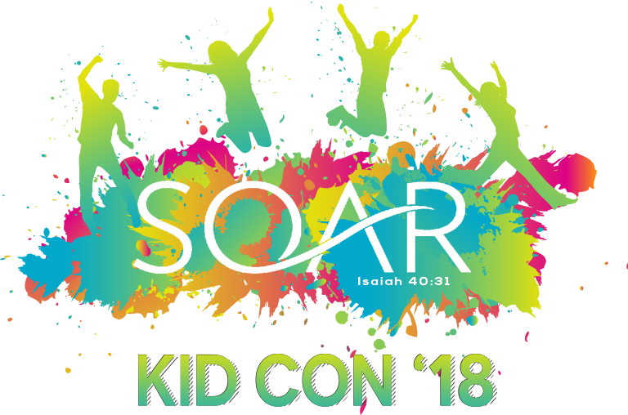

Who: All students 1st-6th grade
When: Friday August 31st- Saturday September 1st
Where: Christian Life Assemblies of God
5917 66th St, Lubbock, Tx 79424
Cost: Students-$40
Leaders- $25

KIDCON is an event that was created just for kids! All students in 1st-6th grades are invited to join us for this life-changing weekend created to help them experience incredible times with Jesus and friends. Students will engage in powerful worship and encounter the presence of Jesus! This is an opportunity for parents and loved ones to invest in the spiritual formation of their kids and for kids to be impacted by God with kids from across West Texas.

Lodging & Meals
- Both are included in the registration fee
- Lodging will be provided at Christian Life Assemblies of God
- Meals will be provided by Christian Life Assemblies of God

What to bring
- An overnight bag (pajamas, change of clothes, toiletries)
- Bedding (sleeping bag & pillow etc.)
- Bible
- Notebook or journal and pen

Communication
- Students may bring their cell phones or other devices in or to communicate with parents/guardians, but their usage will be limited to communication with parents/guardians.
